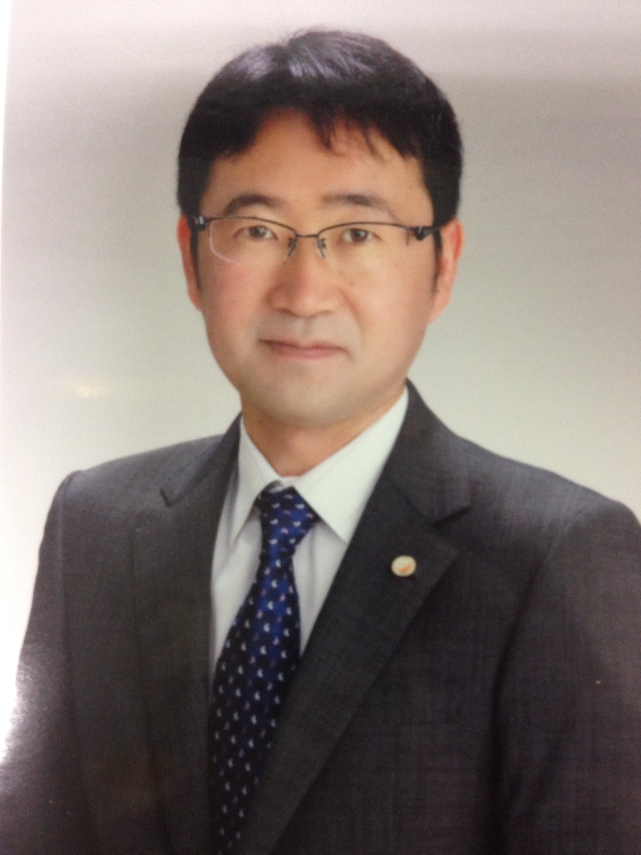
Name: Hideaki Yasuhara

Affiliation : Graduate School of Science and Engineering,
Ehime University
Title : Professor
Birth Date : November 27, 1975 (age: 44)
Telephone : 089-927-9853
Email : hide@cee.ehime-u.ac.jp

Researchers/Students
If you are a non-presenter, no need to write here.
Presentation title
Tackling various engineering problems in the environments influenced by thermo-hydro-mechanical-chemical coupling process: from geologic disposal of high-level radioactive wastes to shale gas

Research theme
- Investigation of properties of permeability, mass transport and mechanics of fractured bedrocks in the environments influenced by thermo-hydro-mechanical-chemical coupling process
- Development of grouting technique utilizing microbial metabolism and biocatalyst
If you do not think of any, no need to write here.
Things that you can cooperate with others
- To conduct laboratory experiments: permeability tests of rock samples controlled in temperature and confining pressure
- To perform numerical analyses: analyses using TOUGHREACT and COMSOL

Companies
If you present in the session of company introduction, write “Yes”, and if not, write “No”.
Company introduction
Yes

Content of business
Construction and development both inside and outside Japan: bridges, roads, tunnels, dams, railways, plants, nuclear projects etc.

Projects or researches that you have engaged in
- Tunnels：XXX tunnel, YYY tunnel
- Nuclear projects: Investigation of properties of permeability, mass transport and mechanics of fractured bedrocks in the environments influenced by thermo-hydro-mechanical-chemical coupling process
- Development of soil improvement techniques: Development of grouting technique utilizing microbial metabolism and biocatalyst
If you have nothing to announce, no need to write here.
Recruitment or internship information
- Internship in every August: facility tour and technical training for 4 days
- Recruitment information is disclosed in the middle of October every year.
Notes
1. There are two categories, “Researchers/Students” and “Companies”. You can choose either one or both to fill in and delete the rest.
2. Each category should occupy no more than a half of A4-size sheet.
3. This form will be published in a conference booklet, so please do not write what you do not want disclose.

